Planning Consideration for The HR Project
Name
Institution

Planning Consideration for The HR Project
Introduction
Project management is a critical process that entails applying processes, knowledge, skills knowledge, and techniques to achieve specific goals and objectives within a given timescale. Project management is different from normal management since it has final deliverables and a specific timescale, while normal management is an ongoing process with no specific time scale (Khan,2012). Project managers need to have a wide range of skills and knowledge that would help to achieve the specific goals and objectives. In a project-oriented organization, human resource management plays a great role in performing business processes and achieving strategic objectives. As a project manager, I have organized my team and started to plan the project, which will integrate many factors such as scope, resourcing, budgeting, and risk management.
Question 1
Project scope is a detailed outline of all aspects of a project, including project boundaries, timelines, deliverables, resources, and deliverables. Developing a project scope is the first phase of project management. This helps the project managers plan, control, and organize all project features and, hence, achieve the set goals and objectives effectively (Khan,2012). Additionally, including specific elements in the scope statement helps minimize the risk of change orders and disruptions while remaining on the estimated cost. The elements included in the scope statement include the business case, which explains the need for the project, project description, success criteria, limitations, and assumptions. A proper definition of project scope helps the project managers to manage the project successfully. In this case, the project manager needs to work with the key stakeholders to identify the scope and scope to ensure that essential things do not fall through the cracks. Additionally, the project managers, together with the key stakeholders need to identify and communicate the project elements that are assumed to be true for the project's duration. Assumptions are necessary for project management since they provide an estimate of cost and the timescale used to achieve the set goals and objectives.
The project scope and schedule are important to the managers and the entire team since they define the boundaries of the project. In this case, the scope statement provides a clear understanding of the project, forming the basis for the project plan. The project scope statement defines the activities that are part of the project and those outside the project hence providing a common understanding among the stakeholders. Additionally, the project managers use the project scope to evaluate the modifications required to make the project more successful. Poorly managed change may cause severe harm to the project leading to missed deadlines, misuse of the allocated resources, and even project failure.
Question 2
For project managers to effectively perform their roles and responsibilities, there are diverse skills and a wealth of knowledge that they need to have that would also help them handle the challenges they face. In most cases, managing a project entails getting things done through other people. Hence, there is the need for project managers to have interpersonal and behavioral skills that would help them to deal with people. Effective communication is one of the behavioral skills that are associated with project resourcing. In this case, the project managers need to ensure that all the guidelines and procedures are communicated clearly to the team members (Pettersen,2011). The project manager can monitor the project's progress and hence achieve the set goals and objectives within the set timeline and budget.
Similarly, team building skill is also fundamental in project resourcing since the project manager will be able to mold his or her team into a unified entity with a common goal. In this case, the project manager can learn the abilities and personalities of each member and hence capitalizing on a member's strength in the proper situation. The project managers need to lead by example than just giving out orders to the team members. For effective achievement of project goals and objectives, the project managers need to set direction by helping the team members see what lies ahead and solve the problems that may arise when performing the allocated tasks. By being the example of greater discipline and greater drive, the project manager encourages the project team to adopt a higher standard and achieve the set goals and objectives of the project within the set timeline and budget.
Question 3
Project budget is a plan that outlines the monetary resources required to meet the goals and objectives of a specific task within a given period. A project managerrelies on the project budget to make appropriate decisions concerning different aspects such as time, scope, and cost. Project budget management is the process in which the project managers identify, approve, and pay the expenses incurred in achieving the set objectives and goals of the project. In this case, a project manager uses the purchase order forms to set out a set of expenses such as material, equipment, and training costs. The initial step in project planning is to perform the project budgeting process, which is conducted parallel with the project scheduling process. However, the stages in the budgeting process depend on other factors such as cost estimations, project duration, and available resources.
The project manager needs to work with other project stakeholders to design and estimate the costs of individual activity. In conducting budgeting activities, the manager uses the work break down structure to identify the monetary resources required to achieve the set goals and objectives of the project. The cost aggregation will be performed by considering the individual approximations for each activity and aggregate upward to work package level, then role the identified approximations to a high level, sub-deliverable level, and deliverable level to determine the bottom-up approximation for a given percentage of the project or the whole project.
In all projects, cash flow is the most important statement since the input and output of monetary resources are predicted. Many cash flows are constructed with multiple periods depending on the nature of the project. Two forms of accounting are used to determine the cash flow for different activities, including accrual accounting and cash accounting. The accrual accounting method reports income when earned, regardless of when the payment is received, and the expenses are reported when incurred but not when the payment is made. On the other hand, cash accounting approach reports income when it is received, and the expenses when they are paid. Our project used the accrual accounting method where expenses were recorded when incurred, and the income was recorded when earned rather than when received.
Question 4
Project risk refers to a condition or uncertain event that interferes with at least one project's objective if it occurs. The most common types of project risk include cost risk, schedule risk, and performance risk. Identification of project risk is the most important step in project management since it determines how well the project managers would implement mitigating measures and achieve the set goals and objectives of the project (Kasap& Kaymak,2013). There is a range of tactics that project managers can use to determine project risk, which include assumption analysis, SWOT analysis, and documentation review. Assumption analysis entails identifying the factors that are considered to be true without proof or demonstration and their impacts on the project goals and objectives.
Similarly, SWOT analysis helps the project managers see the project from the competitive environment's perspective. The factors that are analyzed include the strength, weaknesses, opportunities, and threats of the project. Documentation review as a risk identification method requires the project managers to research previous, similar projects or even projects performed by other entities to get technical details about the project. Reviewing backgrounds and technical details on the project team, and other data would help identify some major risks that would greatly impact the goals and objectives of the project if not properly managed.

Question 5
Project Budget
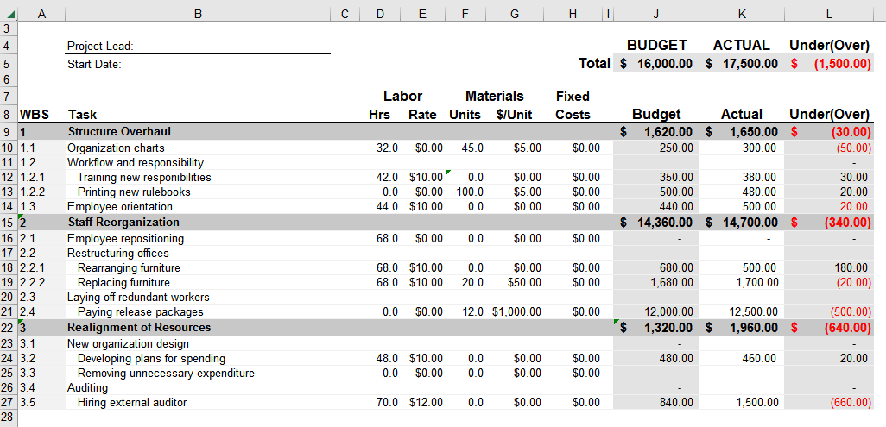

Reference
Kasap, D., &Kaymak, M. (2013, August). Risk identification step of the project risk management. In PICMET'07-2007 Portland International Conference on Management of Engineering & Technology (pp. 2116-2120). IEEE
Khan, A. (2012). Project scope management. Cost engineering, 48(6), 12-16.
Pettersen, N. (2011). What do we know about the effective project manager?.International Journal of Project Management, 9(2), 99-104.
.

